Task 14 – Evidence Report
Handing Over the DSYS601 Observability Lab
Student | Kabir Singh Thukrai
Student ID | 99281336
Course | BCIS309 – Work Integrated Learning Project
Task | Task 14 – Standing lab environment handover, documented and rebuildable on nominated host hardware
Release tag | v1.2-handover
Repository | https://github.com/kat0870/dsys601-k8s-observability-lab
Date | 30 September 2026

1. What this task was about
The brief asks for the lab to be handed over so it can be rebuilt on the machine the course will use. So the real question was: can someone else take a blank college machine and build the whole lab from my repo and guide, without me?
I did this in two parts. First I got the repo ready for a new person. Then I tested it on a fresh copy of the college Ubuntu machine.

2. Getting the repo ready
I checked my dev VM first. The lab needs about 6.5 GB of disk, and the 20 GB disk only had 3 GB left (Figure 1). So I set the minimum for the course machine at 4 cores, 8 GB memory and 40 GB disk.
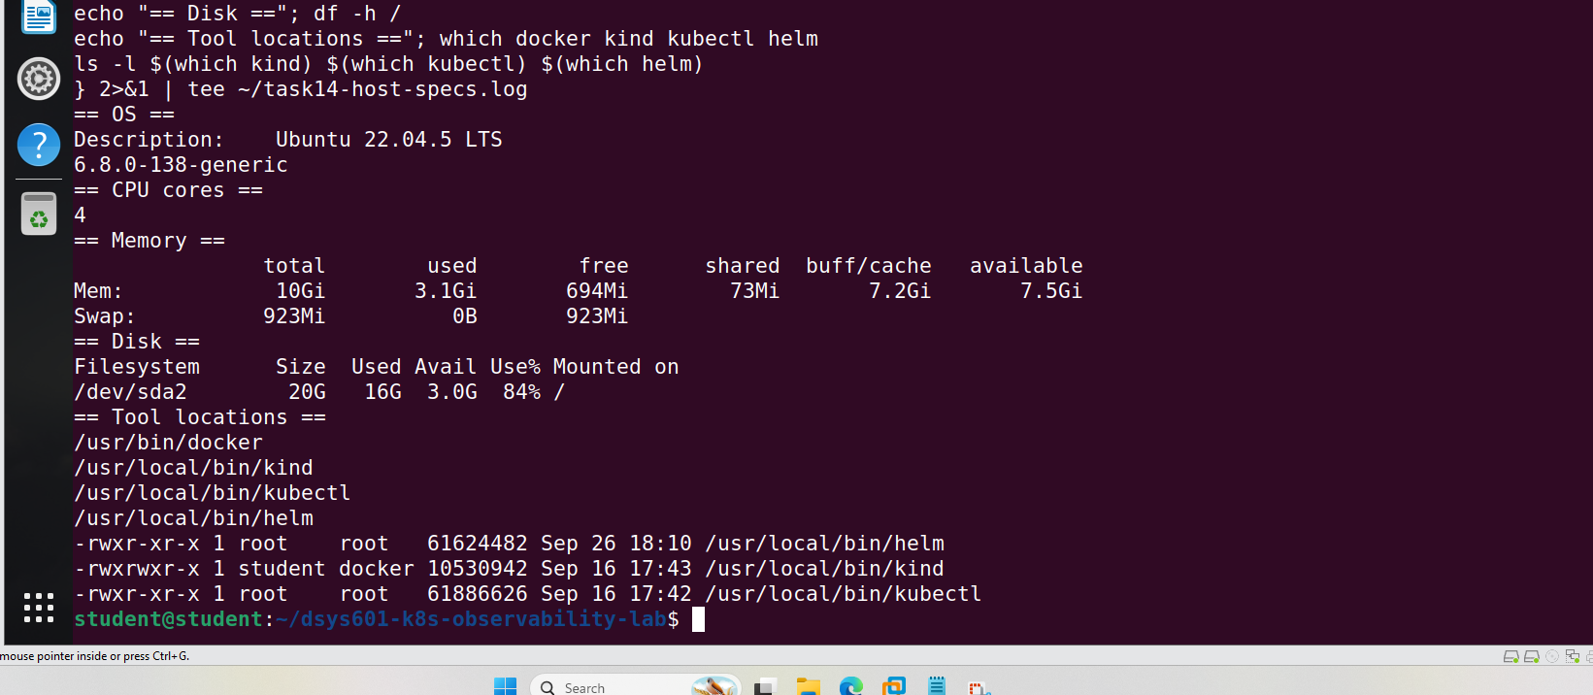
Figure 1. Dev VM: 4 cores, 10 GB memory, but only 3 GB of disk left
Kind was still an alpha build, which a new machine cannot easily download. I moved it to the normal v0.33.0 release, which uses the same node image, and ran a full reset. It passed all 11 checks (Figure 2).
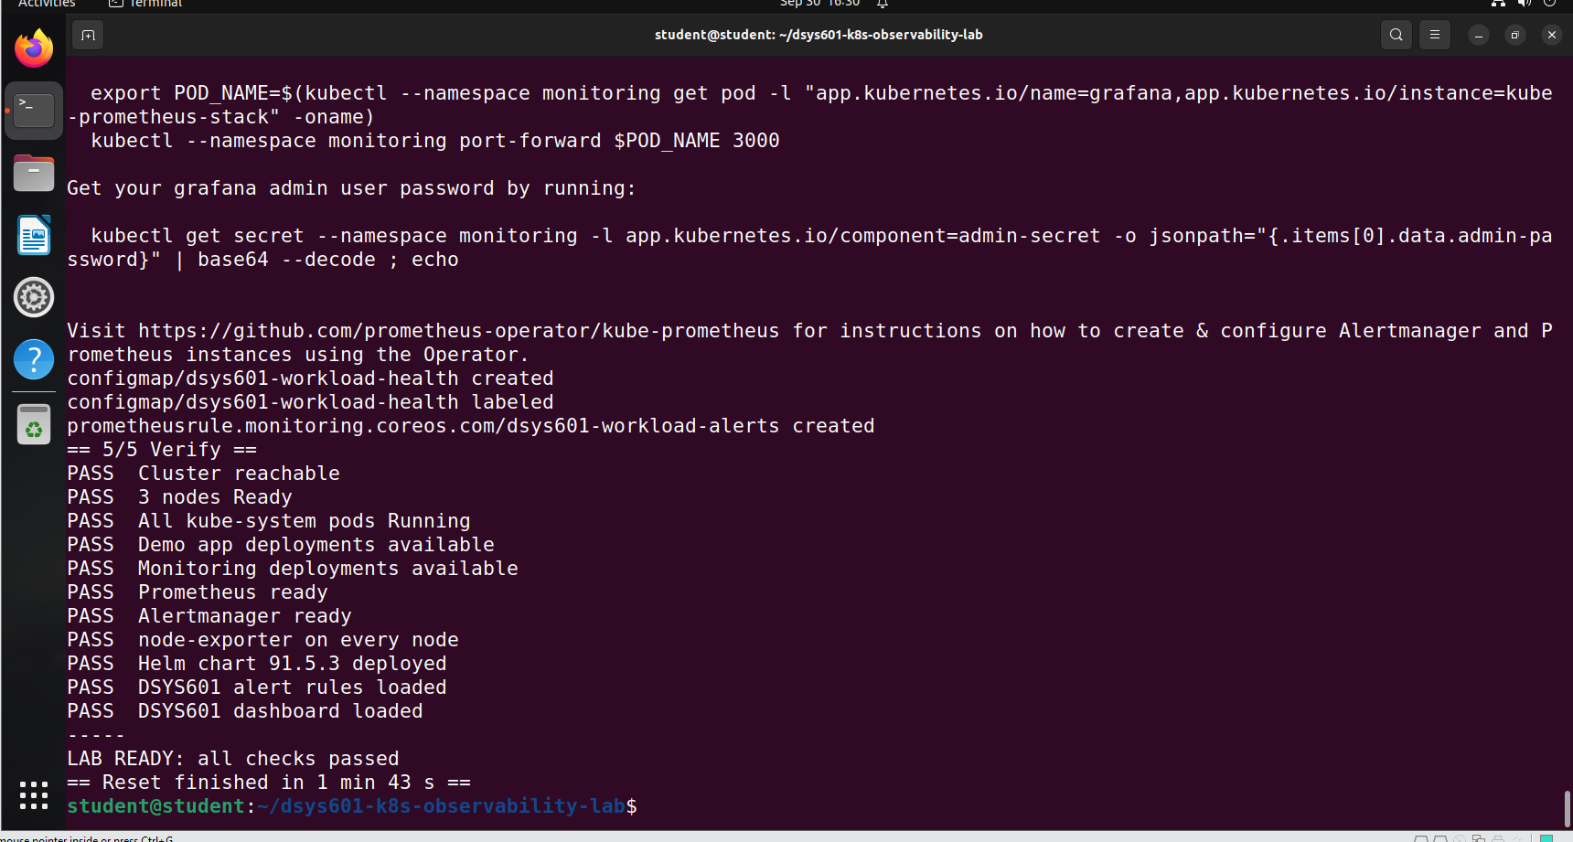
Figure 2. Reset with Kind v0.33.0: LAB READY
I then wrote install-tools.sh. It installs Docker, kubectl, Helm and Kind at the pinned versions, checks each download, and applies the cgroup fix that Kind needs on these Ubuntu VMs. On my dev VM everything was already in place, so it installed nothing (Figure 3).
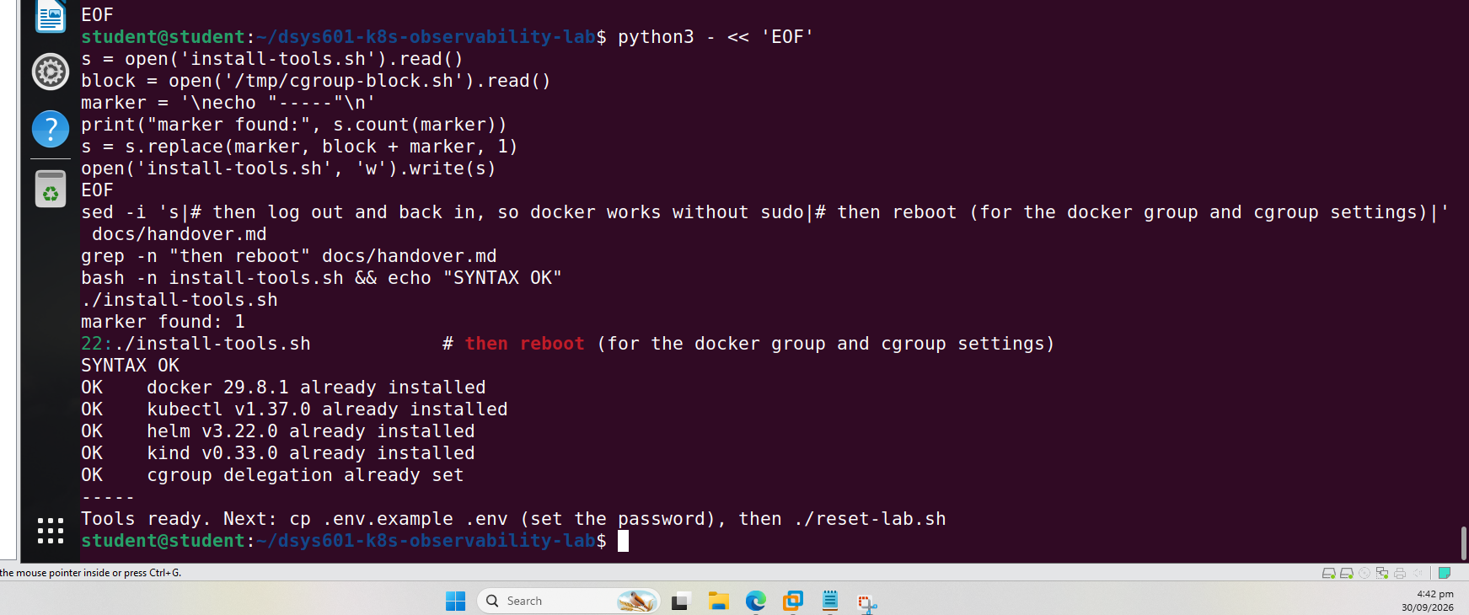
Figure 3. install-tools.sh on the dev VM: everything already OK
Last, I wrote docs/handover.md, a short guide for tutors, and updated the README. All of this was pushed to GitHub (Figure 4).
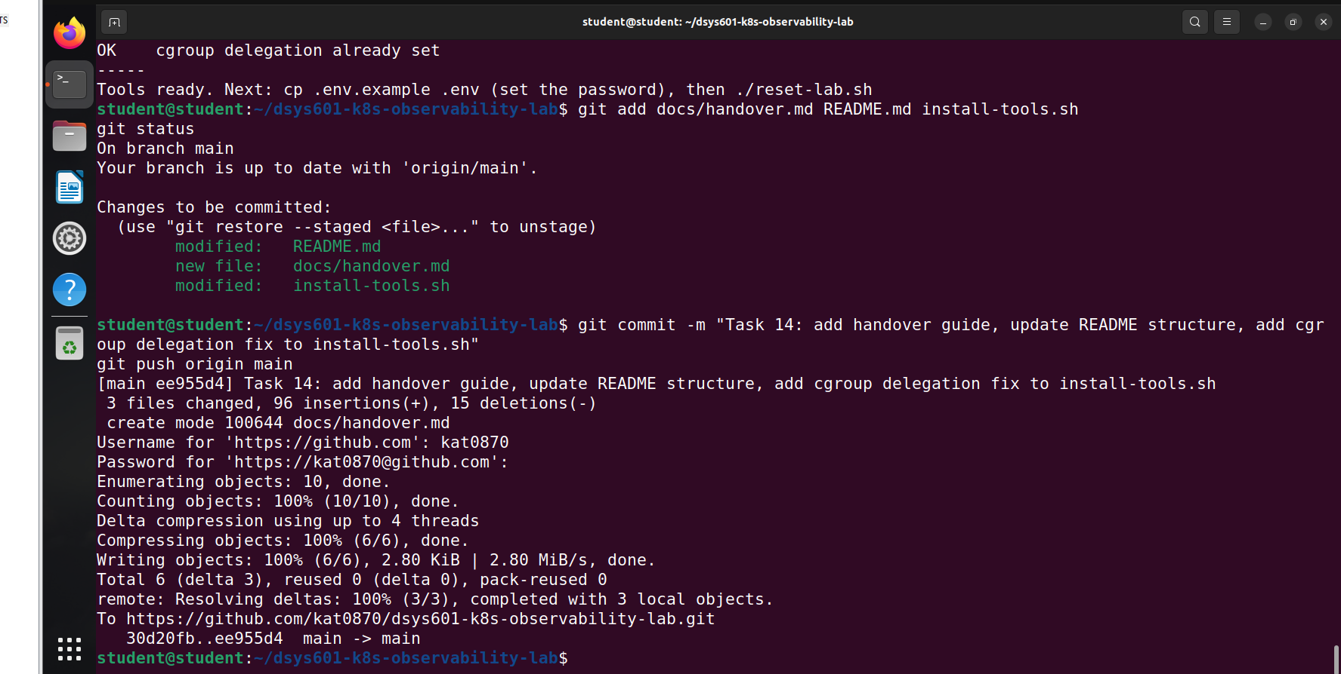
Figure 4. Handover guide and install script pushed to GitHub

3. Setting up a fresh test machine
For the test I used the college "Ubuntu 224 LTS" base VM from P:\Clones, the same Ubuntu release the lab was built on (Figure 5).
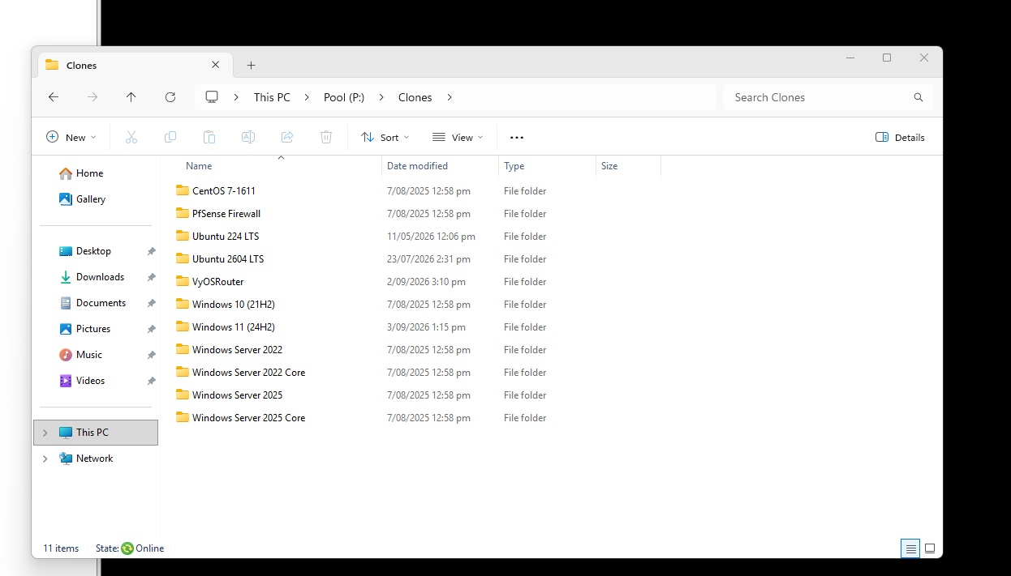
Figure 5. College base VMs. I used Ubuntu 224 LTS
I set it to the minimum spec: 4 cores and 8 GB memory. The college VMs are linked clones, so VMware would not let me make the 20 GB disk bigger. Instead I added a second 40 GB disk for Docker (Figure 6) and mounted it at /var/lib/docker (Figure 7).
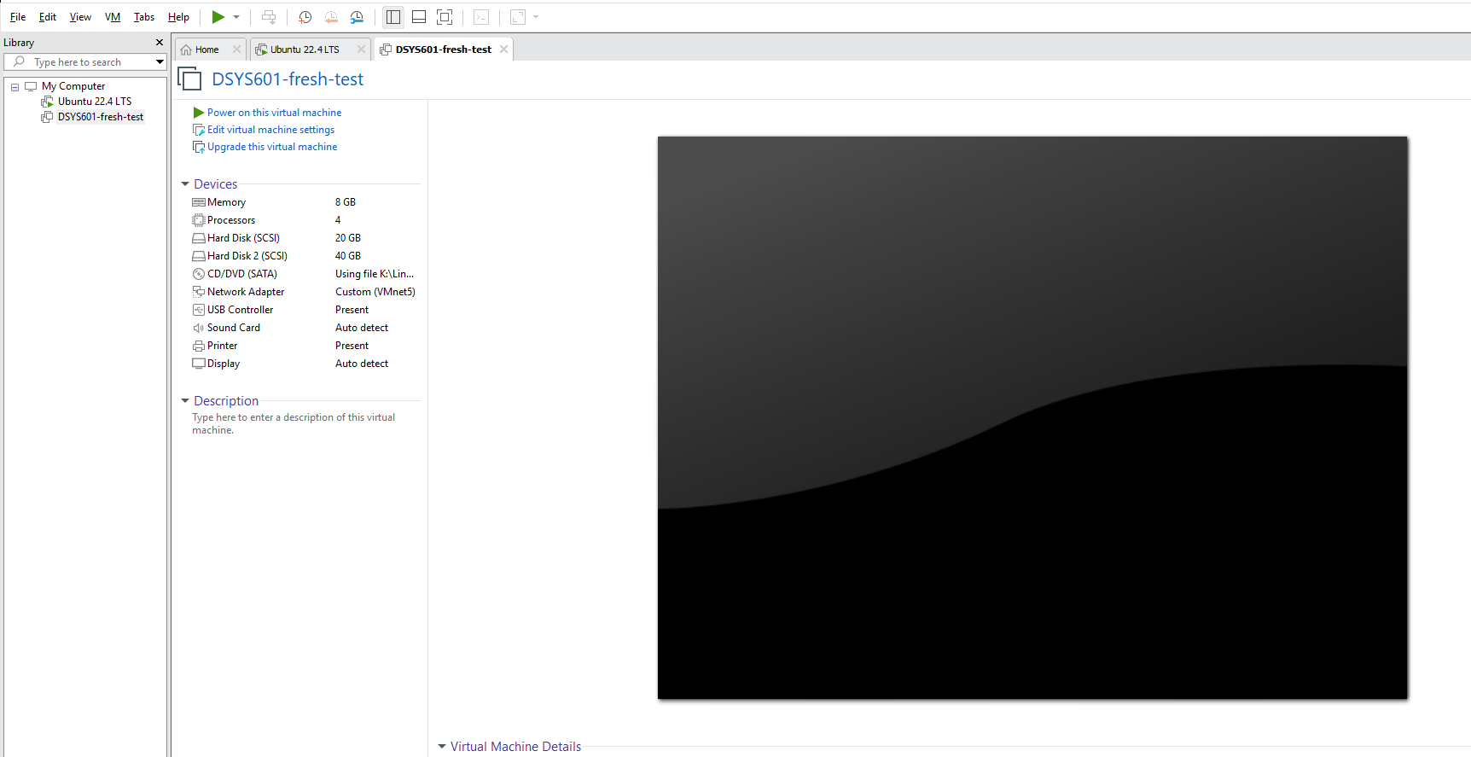
Figure 6. Test VM: 4 cores, 8 GB memory, 20 GB disk plus a 40 GB disk
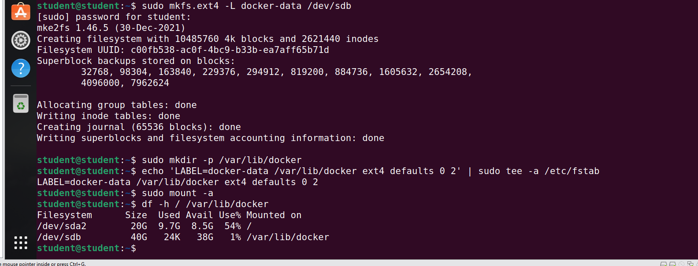
Figure 7. The 40 GB disk mounted at /var/lib/docker
Before starting, I checked the machine was clean: none of the lab tools were installed, and it did not even have git or curl (Figure 8).
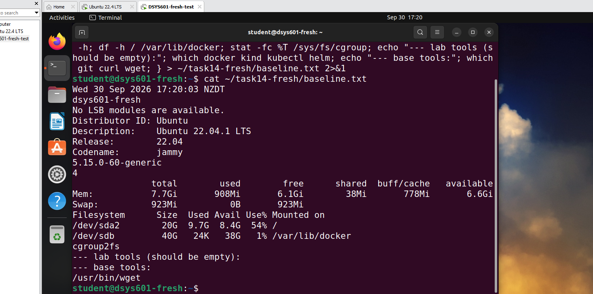
Figure 8. Clean starting point: no lab tools installed

4. Following the handover guide
From here I only followed docs/handover.md. I installed git, cloned the repo and ran install-tools.sh. It took about 20 minutes on the college network. All downloads passed their checksum checks, and it found the cgroup fix was really needed on this machine (Figure 9).
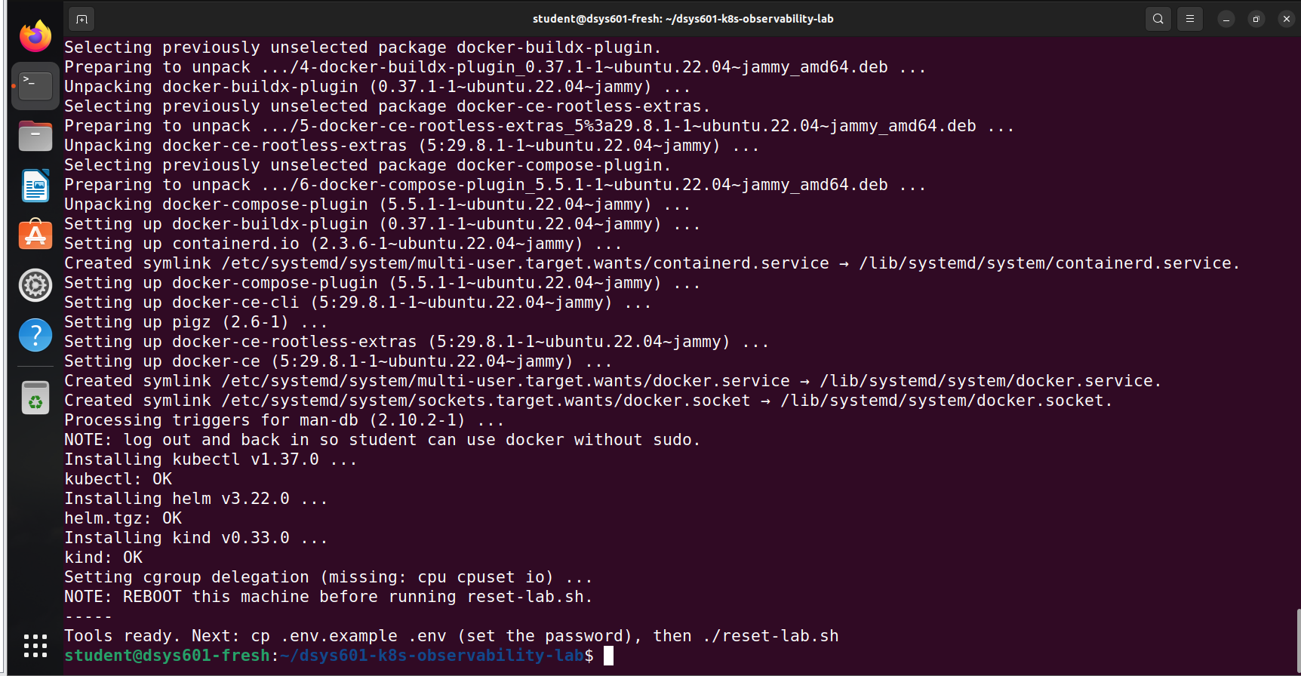
Figure 9. install-tools.sh on the fresh machine
After a reboot, docker worked without sudo and the cgroup settings were in place (Figure 10).
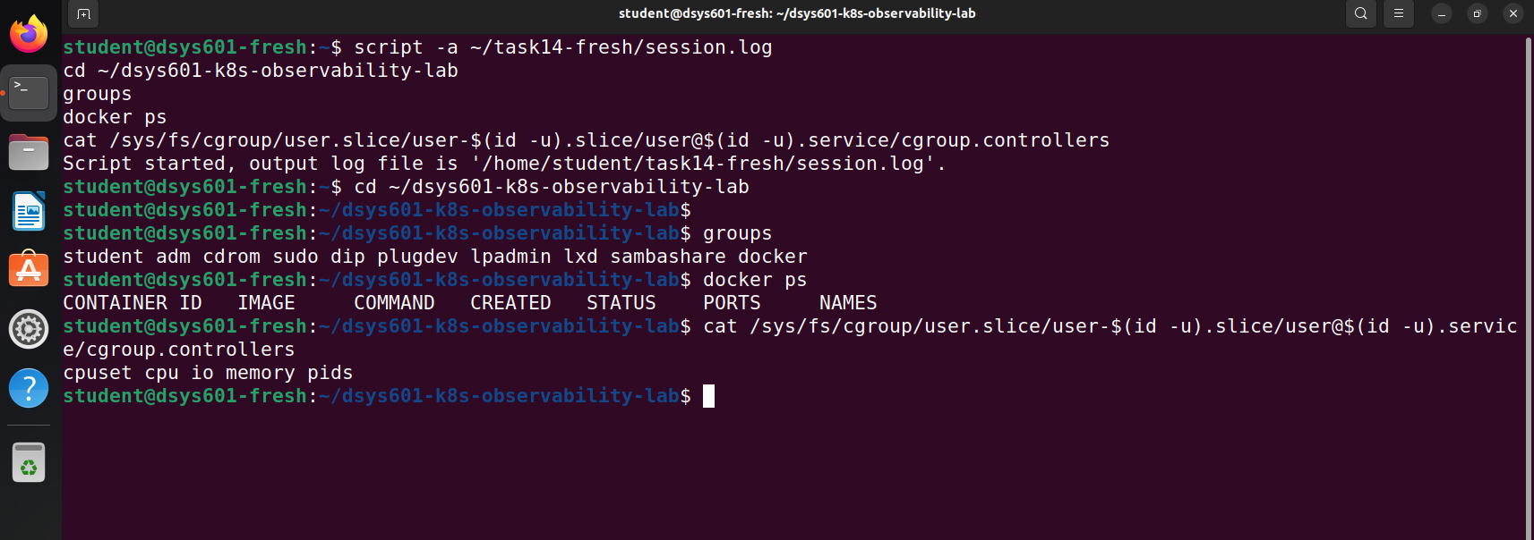
Figure 10. After the reboot: docker and cgroup settings working
I set the Grafana password in .env and ran reset-lab.sh. It built the whole lab and passed all 11 checks in 1 min 41 s (Figure 11). The lab used about 7 GB of disk in total.
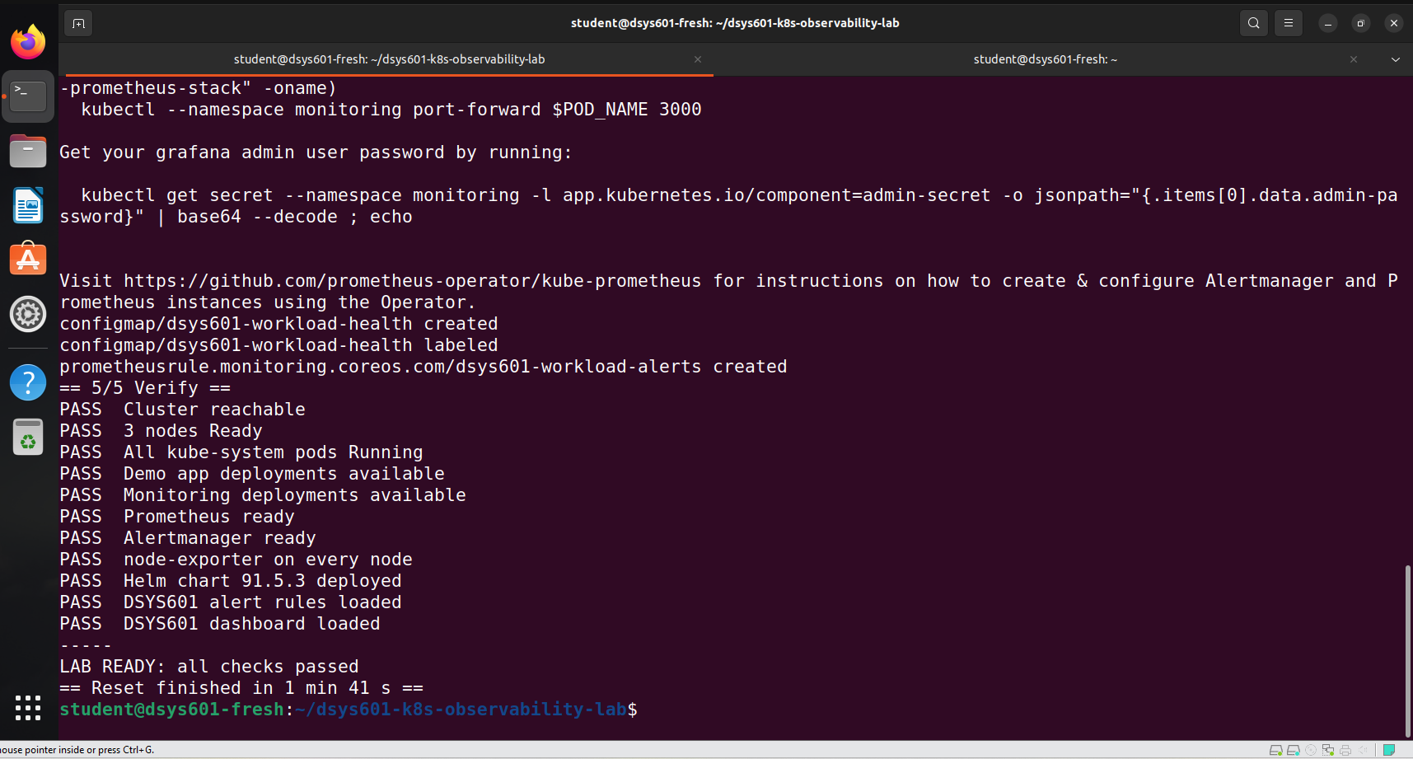
Figure 11. reset-lab.sh on the fresh machine: LAB READY

5. Checking it works
I opened Grafana using the command in the guide. The DSYS601 Workload Health dashboard showed live data (Figure 12), and all four DSYS601 alert rules were loaded (Figure 13).
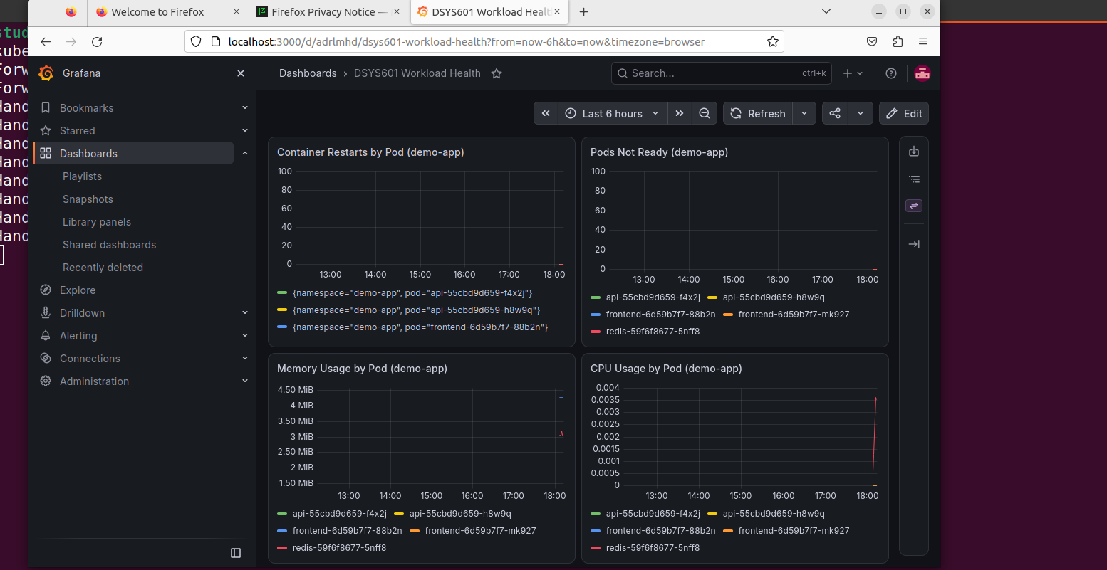
Figure 12. DSYS601 dashboard on the fresh machine
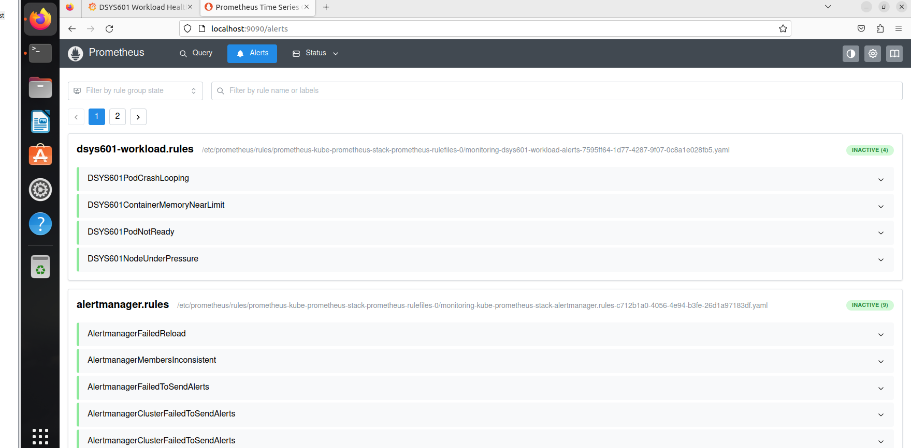
Figure 13. All four DSYS601 alerts loaded
Then I ran the crashloop failure test from the guide. The DSYS601PodCrashLooping alert fired after about 9 minutes (Figure 14).
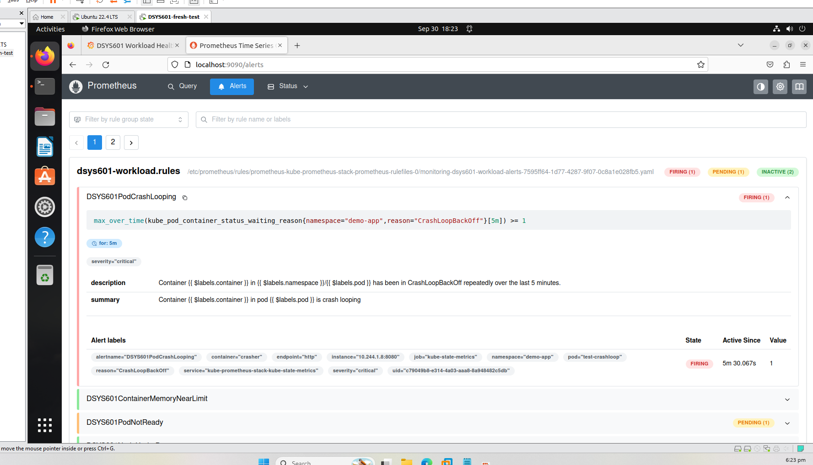
Figure 14. Crashloop alert firing
After I deleted the test pod, the lab went back to 11/11 (Figure 15), and the alert cleared about 5 minutes later.
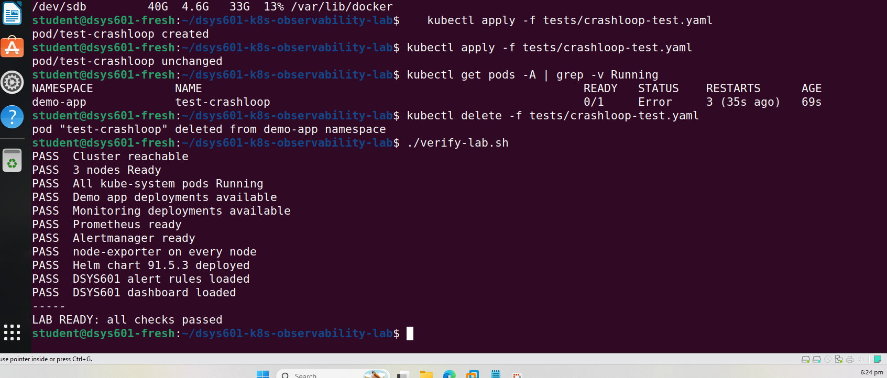
Figure 15. Test pod removed, lab back to 11/11

6. What I changed after the test
What I found | What I did
College VMs are linked clones, so the disk cannot be made bigger | Added steps to the guide for adding a second 40 GB disk
The college image has no git or curl | No change needed: the guide installs git and the script installs curl
The crashloop alert took about 9 minutes, not 7 | Changed the guide to say 7 to 9 minutes
The lab worked on Ubuntu 22.04.1 as well as 22.04.5 | Added this to the guide

These changes were pushed and tagged v1.2-handover (Figure 16).
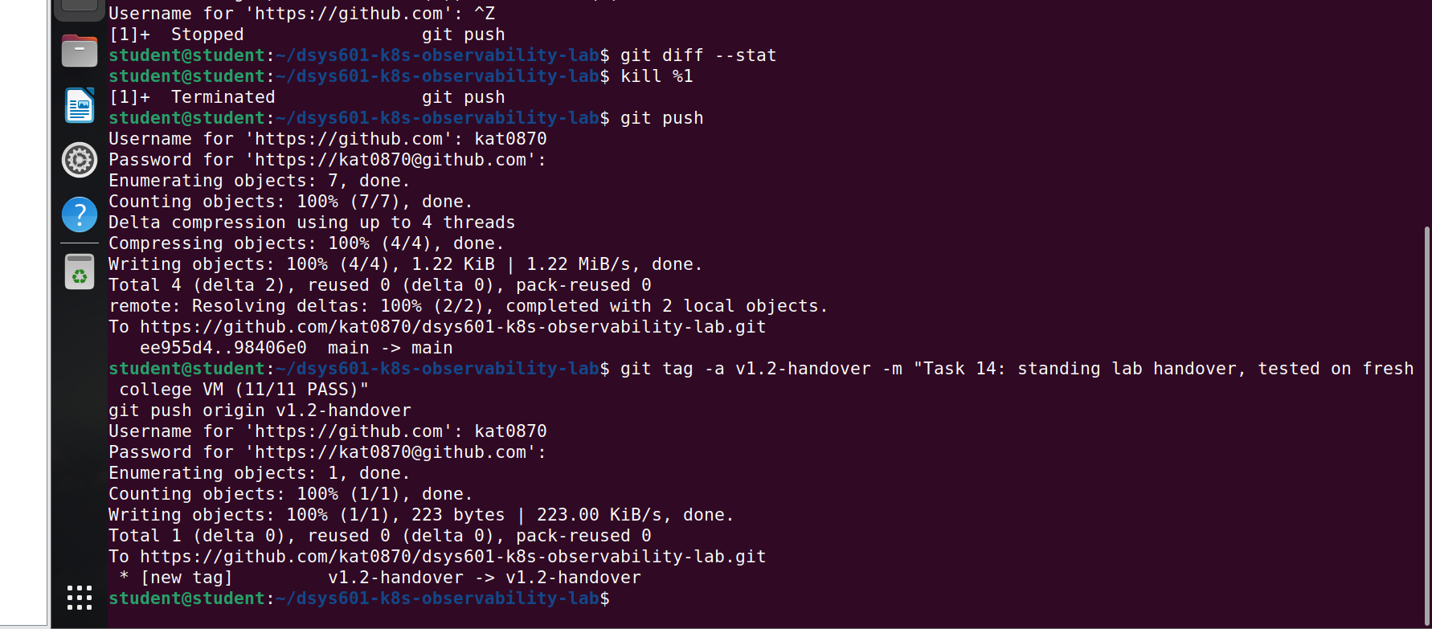
Figure 16. Final changes pushed and tagged v1.2-handover

7. Where this leaves Task 14
Brief requirement | Covered by
Documented | docs/handover.md: requirements, setup, access, everyday commands and fixes
Rebuildable | A fresh college VM became a working lab using only the repo and the guide
Tested | 11/11 checks, dashboard working, crashloop alert fired and cleared
Known-good version | Tag v1.2-handover

Task 14 is complete. The one thing still to confirm is which machine the course will actually use. The guide works on the college Ubuntu image, so it should only need the disk set up as described. Next is Task 15, writing the DSYS601 labs.
Repository: https://github.com/kat0870/dsys601-k8s-observability-lab

